1. Creating and Renaming Files/Directories

a. Create a directory named test_dir using mkdir.

Command :

mkdir test_dir

touch test_dir/example.txt

Explanation: This command creates a folder called test_dir and an empty file named example.txt

inside it .

b.Inside test_dir, create an empty file called example.txt.

Command :

touch test_dir/example.txt

Explanation : Using touch command we can create a new file

c. Rename example.txt to renamed_example.txt using mv

Command :

mv test_dir/example.txt test_dir/renamed_example.txt

Explanation : MV is the command that use we can copy or change the name of our file as well as our dircotry .

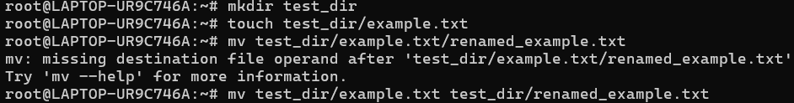

2. Viewing File Contents

a. Use cat to display the contents of /etc/passwd.

Command :

cat /etc/passwd

Explanation: The cat command in Linux is used to **view**, **create**, or **combine** files.

b. Display only the first 5 lines of /etc/passwd using head.

Command :

head -n 5 /etc/passwd

Explanation: head is use to display upper line -n 5 is say to display upper 5 line given folder

c. Display only the last 5 lines of /etc/passwd using tail.

tail-n 5 /etc/passwd

Explanation: head is use to display lower line -n 5 is say to display lower 5 line given folder.

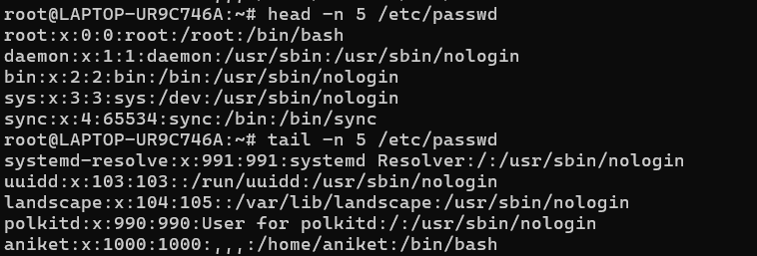

3.Searching for Patterns

a. Use grep to find all lines containing the word "root" in /etc/passwd.

Command :

grep "root" /etc/passwd

Explanation: This commcommand and searches for the word **"root"** in the file **/etc/passwd** and displays all lines that contain it.



4. Zipping and Unzipping

a. Compress the test_dir directory into a file named test_dir.zip using zip.

Command :

zip -r test_dir.zip test_dir/

Explanation : This command compresses the folder test_dir/ into a zip file called

test_dir.zip.

b. Unzip test_dir.zip into a new directory named unzipped_dir.

Command :

unzip -r test_dir.zip test_dir/

Explanation : This command extend the folder test_dir/ into a unzip file called

test_dir.zip.

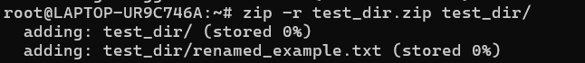

6. Changing Permissions

a. Create a file named secure.txt and change its permissions to read-only for everyone using chmod.

Command :

root@LAPTOP-UR9C746A:~# chmod 444 secure.txt

Explanation : chmod this command is use to change the permission , the number is 444 is only give the read permission to user,group and public .



7. Working with Environment Variables

a. Use export to set a new environment variable called MY_VAR with the value "Hello, Linux!".

Command :

export MY_VAR="Hello, Linux!"

Explanation : This command **creates and exports** a new environment variable named MY_VAR with the value "Hello, Linux!".

